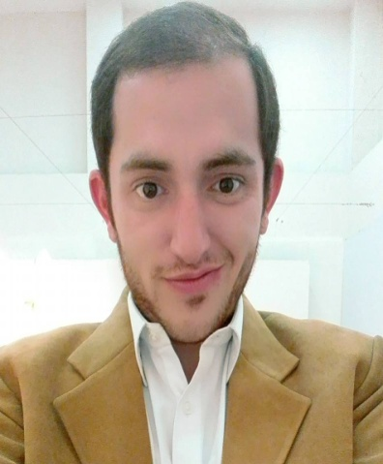

Ahmed Elahi

145-CMA Colony Allow-e-Din Road Lahore Cantt

Mobile: 03218813304 E-mail: ahmedelahi29@gmail.com

Personal Profile

Graduated on 21st August 2019 with a degree of BA Hons In Social Sciences With Major In Theatre, Film and Television. Scored B grade in thesis project which was a short film called "Chai" its genre was romantic, drama, comedy. It was my original work; its duration was 15 minutes and 11 seconds. I wrote the story and the script, directed it and produced it.
I have written a few short stories, 2 to 3 theatre plays for university and I have done acting as a lead and as a supporting actor for other people in theatre plays and short films.
The stories that I like to write are mostly comedy but the issues are sometime really serious, issues which portray the picture of our society. Even my thesis film was about a young couple trying to reconcile over a cup of tea, after having an argument. But the moral of the story was that in every situation if we think and try to stay relaxed instead of getting angry and overreacting, then we can save our self and our relations from many different disasters. Because we drag things allot due to which even a small issue causes allot of emotional and psychological damage to the other person who is innocent.

I like reading books which are mostly Religious Philosophy because Philosophy and Theology have played a very vital role in giving a structure to my Being.

Achievements

- Done with Bachelors degree in BA Hons in Social Sciences with Major in Theatre, Film and Television with a B grade in thesis short film.
- Run a YouTube channel called “Come closer to life with Ahmed Elahi” in which I talk about the different characteristics of our society and try to bring in front the hidden reality this material world.
- Know how to sell a product. Have been doing small business of unstitched clothes, just to make extra pocket money.
- Have been to many countries and states like USA, Europe, Malaysia and etc through which I learned the different ways of living in a society that people practice.

Education

[2010 – 2012] [Matric with computer scineces] [Garrison Boys High School]
Grade achieved: [Passed with 3rd Division]

[2012 – 2014] [Intermediate in Commerce] [Forman Christian College]
Grade achieved: [Passed with 3rd Division]

[From – To] [BA Hons in Social Sciences with Major in Theatre, Film and television] [Beaconhouse National University]
Grade achieved: [SGPA 3.09 and CGPA 2.56 (8th semester)]

Work Experience

[From – To] [Job Position] [Company name]
2018 Januray Assistant Director, Played a supporting role (theater) Kopykats

The job that I have mentioned above gave me an opportunity to work under Mr Sajid-Hassan. He was the writer of the play, rest of the experinces doesn’t have any specific date or time because our degree itself was based on practicals”

Skills

Technical: know creative writing.

Interpersonal: Have been an active member of debates in college “Parliamentary debates and Model United Nations” and other societies like music and Rotaract club.

Other: Public speaker, actor, writer, director, producer.

Hobbies and Interests

Writing, reading philosophy, reading theology, researching, acting, direction, producing, watching movies, listening music, musical instruments, travelling around the world and trying new food.

